**Stephenson, Sam (1933-2006)**

Sam Stephenson was a controversial Irish architect whose work throughout the 1970s and 1980s sparked debates about BRUTALIST architecture and planning regulations. His best known works included large scale developments for banks, civic and commercial offices in Dublin, often accompanied by protests about the destruction of existing architecture and archaeology. His headquarters for the Electricity Supply Board is a horizontal Miesian design (see Fig. 1), but is more notorious for levelling the central section of Dublin’s Georgian Mile. Only two of his four monumental towers for Dublin Corporation Civic Offices were built, due to the discovery of extensive Viking remains on the site and subsequent popular protests (see Fig. 2 & 3). The Central Bank of Ireland tower was unashamed in its use of unadorned structure (see Fig. 4), with concrete slabs suspended from twin central cores, sparking controversy about planning height regulations in Dublin’s historical centre.

**List of Works**

1958 Stephenson House, 31 Leeson Close, Dublin, Ireland.

1965 Electricity Supply Board Headquarters, Fitzwilliam Street, Dublin, Ireland.

1971 Dublin Institute of Advanced Studies, Burlington Road, Dublin, Ireland.

1970 Irish Pavilion, Expo ’70, Osaka, Japan.

1976 Dublin Corporation Civic Offices Phase 1, Wood Quay, Dublin, Ireland.

1979 Currency Centre, Sandyford, Dublin, Ireland.

1978 Central Bank of Ireland, Dame Street, Dublin, Ireland.

**References and further reading**

Rowley, E. ‘The Conditions of Twentieth Century Irish Architecture 1900-1970’ in Kennedy C. (ed.) (2011) *The Moderns: The Arts in Ireland from the 1900s to the 1970s*, Dublin: Irish Museum of Modern Art, pp. 418-475.

Irish Architectural Archive. Sam Stephenson collection. Accs. 89/24(drawings).

Web References

‘Stephenson, Sam’, *Archiseek*, Available: <http://archiseek.com/2009/sam-stephenson>

*Number 31 Dublin: Boutique Guesthouse Accomodation*, Available: <http://www.number31.ie/>

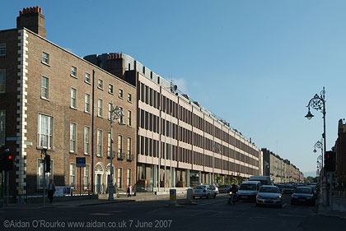

Fig. 1 – Electricity Supply Board Headquarters, Fitzwilliam Street, Dublin, 1965 (Aidan O’Rourke, http://www.aidan.co.uk/display_page.php?photo=IeDFitzwStEsb7607.jpg)

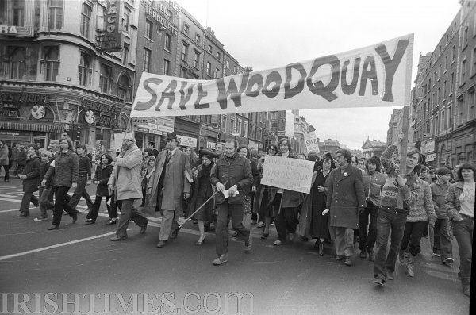Fig. 2 – Wood Quay protests, 1979 (Irish Times photograph 277888, taken by Peter Thursfield, 1979)

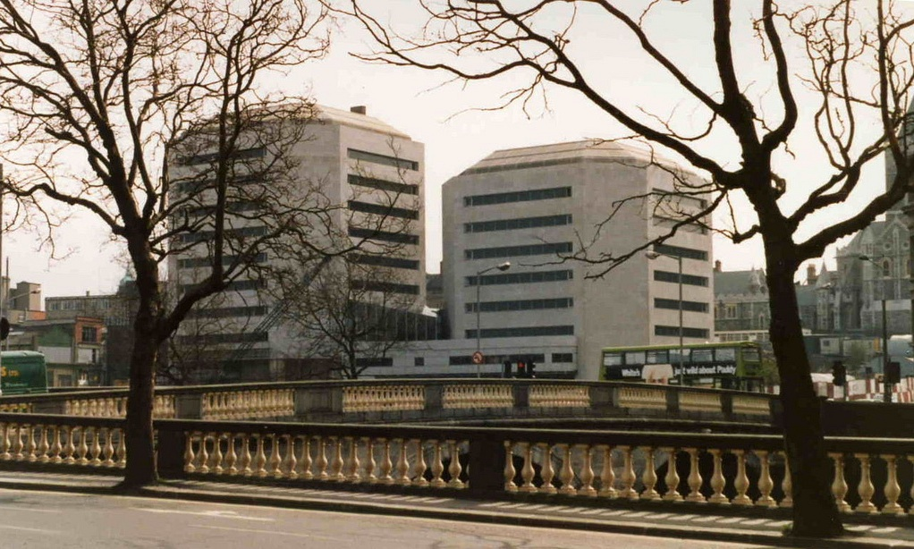Fig. 3 – Dublin Corporation Civic Offices, Dublin, 1976 (<http://www.flickr.com/photos/shamrock_105/6347926999/> N.B. still trying to find a better 1980s photograph than this one from 1985)

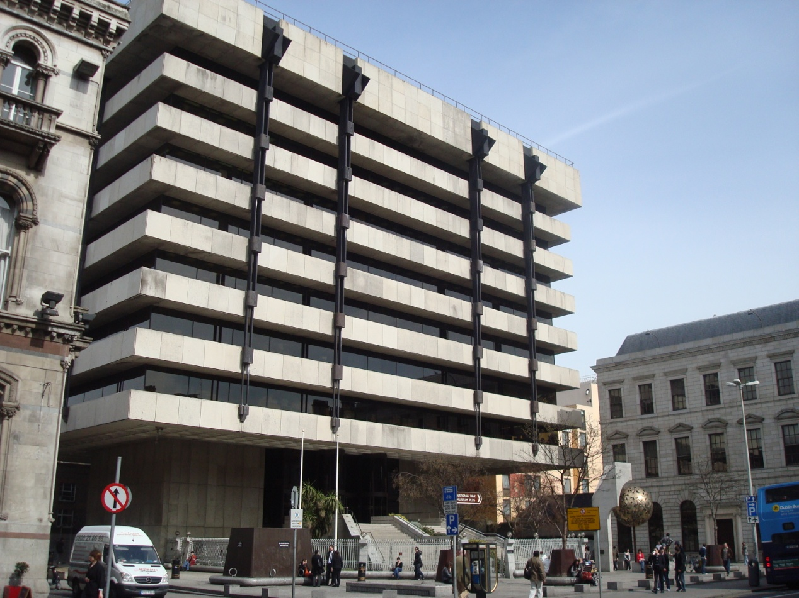Fig. 4 – Central Bank of Ireland, 1978 (<http://upload.wikimedia.org/wikipedia/commons/c/c6/Central_Bank_of_Ireland.JPG> also trying to find a better image than this)

Radio

(2010) ‘Arts Tonight: Sam Stephenson’, *RTÉ Radio 1*, Available:

<http://dynamic.rte.ie/quickaxs/209-r1-artstonight-2010-10-04.smil> (starts at 2:10)